Foodborne disease surveillance and outbreak investigations in Western Australia, fourth quarter 2015

**Enhancing foodborne disease surveillance across Australia**



**Communicable Disease Control Directorate**



OzFoodNet, Communicable Disease Control Directorate

**Acknowledgments**

Acknowledgement is given to the following people for their assistance with the activities described in this report: Mr Damien Bradford, Ms Lyn O’Reilly, Ms Jenny Green, Dr Niki Foster and the staff from the enteric, PCR and food laboratories at PathWest Laboratory Medicine WA; staff from the Food Unit of the Department of Health, Western Australia; Public Health Nurses from the metropolitan and regional Population Health Units; and Local Government Environmental Health Officers.

**Contributors/Editors**

Nevada Pingault and Barry Combs

Communicable Disease Control Directorate

Department of Health, Western Australia

PO Box 8172

Perth Business Centre

Western Australia 6849

Email: [OzfoodnetWA@health.wa.gov.au](mailto:OzfoodnetWA@health.wa.gov.au)

Telephone: (08) 9388 4999

Facsimile: (08) 9388 4877

Web:

OzFoodNet WA Health [www.public.health.wa.gov.au/3/605/2/ozfoodnet_enteric_infections_reports.pm](http://www.public.health.wa.gov.au/3/605/2/ozfoodnet_enteric_infections_reports.pm)

OzFoodNet Department of Health

[www.ozfoodnet.gov.au/](http://www.ozfoodnet.gov.au/)

**Disclaimer**:

Every endeavour has been made to ensure that the information provided in this document was accurate at the time of writing. However, infectious disease notification data are continuously updated and subject to change.

This publication has been produced by the **Department of Health, Western Australia**.

# Executive summary

During the fourth quarter of 2015, the Western Australian (WA) OzFoodNet team conducted surveillance of enteric diseases, undertook investigations into outbreaks and was involved with ongoing enteric disease research projects.

The most common notifiable enteric infections in WA were campylobacteriosis (n=885), salmonellosis (n=470), rotavirus (n=90) and cryptosporidiosis (n=65). Notifications of campylobacteriosis*,* salmonellosisandcryptosporidiosiswere higher than the five-year fourth quarter mean, while rotavirus notifications were lower. The large increase in salmonellosis was driven by the increase in notifications of *S*. Typhimurium PFGE 0001.

Five foodborne outbreaks were investigated in the fourth quarter with two due to *S*. Typhimurium PFGE 0001 and associated with the consumption of egg dishes.

OzFoodNet also conducted surveillance of 48 non-foodborne outbreaks. Of these, the most common mode of transmission was person-to-person (42 outbreaks), with a total of 936 people ill. Norovirus was the most common agent responsible for infection (identified in 22 outbreaks), and most outbreaks were in aged care facilities.

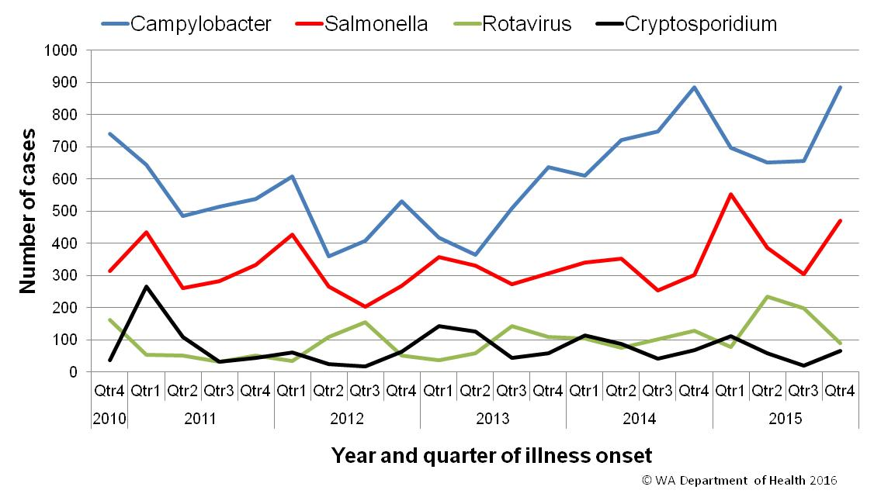

Figure 1 Notifications of the four most common enteric diseases by quarter from 2010 to 2015, WA

**Table of Contents**

Executive summary 2

1 Introduction 5

2 Incidence of notifiable enteric infections 6

2.1 Methods 6

2.2 Campylobacteriosis 6

2.3 Salmonellosis 7

2.4 Rotavirus infection 8

2.5 Cryptosporidiosis 9

2.6 Other enteric diseases and foodborne illness 10

3 Foodborne and suspected foodborne disease outbreaks 12

3.1 Frozen berries, hepatitis A (outbreak code 019-2015-002) 12

3.2 Cafe, *Salmonella* Typhimurium MLVA 3-10-(14/15/16)-11-496 (outbreak code 042-2015-009) 12

3.3 Dinner party, *Salmonella* Typhimurium MLVA 03-26-13-11-523 (Outbreak code 042-2015-010) 12

3.4 Primary produce, Salmonella Muenchen (outbreak code 042-2015-012) 13

3.5 Graduation dinner, unknown pathogen (outbreak code 11/15/MBC) 13

4. Cluster investigations 13

4.1. *S.* Typhimurium PFGE 0001, phage type 9 13

5. Non-foodborne disease outbreaks and outbreaks with an unknown mode of transmission 14

5.1. Person-to-person outbreaks 15

5.2. Outbreaks with unknown mode of transmission 16

6. Site activities 16

7. References 17

List of Tables

Table 1 Number of campylobacteriosis notifications, 4th quarter 2015, WA, by region 7

Table 2 Number of salmonellosis notifications, 4th quarter 2015, WA, by region 7

Table 3 Number of rotavirus notifications, 4th quarter 2015, WA, by region 9

Table 4 Number of cryptosporidiosis notifications, 4th quarter 2015, WA, by region 10

Table 5 Summary of number of notified cases of enteric notifiable diseases in WA in the fourth quarter 2015 compared to historical means 11

Table 6 Outbreaks with non-foodborne transmission, 4th Quarter 2015, WA 14

**List of Figures**

Figure 1 Notifications of the four most common enteric diseases by quarter from 2010 to 2015, WA 2

Figure 2 Notifications of *Salmonella* Typhimurium PFGE 0001 in WA, May 2013 to December 2015 14

**Notes:**

1. All data in this report are provisional and subject to future revision.
2. To help place the data in this report in perspective, comparisons with other reporting periods are provided. As no formal statistical testing has been conducted, some caution should be taken with interpretation.

Copyright to this material is vested in the State of Western Australia unless otherwise indicated. Apart from any fair dealing for the purposes of private study, research, criticism or review, as permitted under the provisions of the Copyright Act 1968, no part may be reproduced or re-used for any purposes whatsoever without written permission of the State of Western Australia.

# Introduction

It has been estimated that there are 5.4 million cases of foodborne illness in Australia each year at a cost of $1.2 billion per year1. This is likely to be an underestimate of the total burden of gastrointestinal illness as not all enteric infections are caused by foodborne transmission. Other important modes of transmission include person-to-person, animal-to-person and waterborne transmission. Importantly, most of these infections are preventable through interventions at the level of primary production, commercial food handling, households and institution infection control.

This report describes enteric disease surveillance and investigations carried out during the fourth quarter of 2015 by OzFoodNet WA, other WA Department of Health (WA Health) agencies and local governments. Most of the data are derived from reports to WA Health of 16 notifiable enteric diseases by doctors and laboratories. In addition, outbreaks caused by non-notifiable enteric infections are also documented in this report, including norovirus, which causes a large burden of illness in residential care facilities (RCF) and the general community.

OzFoodNet WA is part of the Communicable Disease Control Directorate (CDCD) within WA Health, and is also part of the National OzFoodNet network funded by the Commonwealth Department of Health2. The mission of OzFoodNet is to enhance surveillance of foodborne illness, including investigating and determining the cause of outbreaks. OzFoodNet also conducts applied research into associated risk factors and develops policies and guidelines related to enteric disease surveillance, investigation and control. The OzFoodNet site based in Perth is responsible for enteric disease surveillance and investigation in WA.

OzFoodNet WA regularly liaises with staff from Public Health Units (PHUs), the Food Unit in the Environmental Health Directorate of WA Health; and the Food Hygiene, Diagnostic and Molecular Epidemiology laboratories at PathWest Laboratory Medicine WA.

PHUs are responsible for public health activities, including communicable disease control, within their respective administrative regions. The PHUs monitor RCF gastroenteritis outbreaks and provide infection control advice. The PHUs also conduct follow-up of single cases of important enteric diseases including typhoid, paratyphoid and hepatitis A.

The Food Unit liaises with Local Government (LG) Environmental Health Officers (EHO) during the investigation of food businesses. The Food Hygiene, Diagnostic and Molecular Epidemiology laboratories at PathWest Laboratory Medicine WA provide public health laboratory services for the surveillance and investigation of enteric disease.

# Incidence of notifiable enteric infections

## Methods

Enteric disease notifications were extracted from the Western Australian Notifiable Infectious Diseases Database (WANIDD) by optimal date of onset (ODOO) for the time period 1st October 2010 to 31st December 2015. The ODOO is a composite of the ‘true’ date of onset provided by the notifying doctor or obtained during case follow-up, the date of specimen collection for laboratory notified cases, and when neither of these dates is available, the date of notification by the doctor or laboratory, or the date of receipt of notification, whichever is earliest. Rates were calculated using estimated resident population data for WA from Rates Calculator version 9.5.5 (WA Health, Government of Western Australia), which is based on 2011 census data. Rates calculated for this report have not been adjusted for age.

## Campylobacteriosis

Campylobacteriosis was the most commonly notified enteric disease in WA during the fourth quarter of 2015 (4Q15), with 885 notifications (Table 1) and a rate of 136 per 100 000 population per year. There was a 33% increase in campylobacteriosisnotifications in the 4Q15 compared with the five year 4th quarter mean (4QM) of 666 notifications. The increase appeared to be due to sporadic disease, as there were no identified *Campylobacter* outbreaks during the 4Q15. At least some of the increase is likely to be due to the introduction by one large private pathology laboratory of polymerase chain reaction (PCR) testing of faecal specimens, which has greater sensitivity than culture techniques.

The place of acquisition of infection was reported for 57% (n=506) of cases, of which 80% (403 cases) were locally acquired and 18% (91 cases) were acquired overseas.

Table 1 Number of campylobacteriosis notifications, 4th quarter 2015, WA, by region



**\***Percentage change in the number of notifications in the current quarter compared to the historical 5-year mean for the same quarter. Positive values indicate an increase when compared to the historical 5-year mean of the same quarter. Negative values indicate a decrease when compared to the historical 5-year mean of the same quarter. Percentage change should be interpreted with caution when the number of cases is small.

## Salmonellosis

Salmonellosis was the second most commonly notified enteric disease in WA in the 4Q15, with 470 notifications (Table 2) and a rate of 72 per 100 000 population per year. The number of salmonellosisnotifications in the 4Q15 was 54% higher than the 4QM (n=305).

Place of acquisition of infection was reported for 72% (n=340) of cases, of which 67% (n=228) were locally acquired, 31% (n=105) were acquired overseas and 2% (n=7) were acquired interstate.

The most commonly reported *Salmonella* serotype was *S*. Typhimurium (STM) (n=204, 43%), and of those cases with information on place of acquisition (n=147, 72%), 91% of cases (n=134) were locally acquired. Pulsed-field gel electrophoresis (PFGE) has been traditionally used for subtyping of STM in WA but this method is being replaced by the national typing method, multi locus variable number tandem repeat analysis (MLVA). The most common PFGE types were PFGE 0001 (n=147, 72%) and PFGE 0039 (n=13, 6%). Cases with PFGE 0001 were interviewed as part of an on-going cluster investigation (see section 4).

Table 2 Number of salmonellosis notifications, 4th quarter 2015, WA, by region



**\***Percentage change in the number of notifications in the current quarter compared to the historical 5-year mean for the same quarter. Positive values indicate an increase when compared to the historical 5-year mean of the same quarter. Negative values indicate a decrease when compared to the historical 5-year mean of the same quarter. Percentage change should be interpreted with caution when the number of cases is small.

*S*. Enteritidis was the second most common *Salmonella* serotype (n=57, 12%), and of those cases with information on place of acquisition (n=56, 98%), nearly all (n=50, 89%) acquired their infection overseas, primarily after travel to Indonesia (n=39, 78%), and almost exclusively to Bali.

The next most commonly notified *Salmonella* serotype was *S*. Paratyphi B bv Java (n=20), which is traditionally acquired overseas. *Salmonella* notifications that did not have a serotype were the next most common group (n=28). Most (59%) of these notifications were from one laboratory that first uses PCR screening for enteric pathogens.

## Rotavirus infection

In the 4Q15 there were 90 notifications of rotavirus infection (14 per 100 000 population per year) (Table 3). There was a 7% decrease in rotavirusnotifications in the 4Q15 compared with the mean of the previous three years. Notifications in public health regions varied in respect to the previous three years, with decreases in five public health regions and increases in four regions. Of the cases with known Aboriginality status, most (97%) cases were non-Aboriginal. The median age was 1 year old (range <1 years to 93 years).

Table 3 Number of rotavirus notifications, 4th quarter 2015, WA, by region



*Percentage change in the number of notifications in the current quarter compared to the historical 3-year mean for the same quarter. Positive values indicate an increase when compared to the historical 3-year mean of the same quarter. Negative values indicate a decrease when compared to the historical 3-year mean of the same quarter. Percentage change should be interpreted with caution when the number of cases is small.

**Rotavirus: comparison to 3 years (2012-2014) of data only because laboratory testing and notification practices (increased use of more specific PCR over antigen testing) have changed since the beginning of 2012.

NA:not applicable as there is a 0 value in the calculation for the 4th quarter % change

## Cryptosporidiosis

In the 4Q15, there were 65 cryptosporidiosis notifications (10 per 100 000 population per year), which was a 19% increase compared to the 4QM (Table 4). Most of this increase was in the metropolitan regions.

The place of acquisition of infection was reported for 68% of cases (n=44) of which 89% (39 cases) were locally acquired.

Table 4 Number of cryptosporidiosis notifications, 4th quarter 2015, WA, by region



**\***Percentage change in the number of notifications in the current quarter compared to the historical 5-year mean for the same quarter. Positive values indicate an increase when compared to the historical 5-year mean of the same quarter. Negative values indicate a decrease when compared to the historical 5-year mean of the same quarter. Percentage change should be interpreted with caution when the number of cases is small.

## Other enteric diseases and foodborne illness

During the 4Q15, other enteric disease notifications included:

* **Shigellosis**: There were 15 shigellosis notifications in 4Q15 that were culture positive, which was a 29% decrease compared to the 4QM (n=21) (Table 5). *Shigella* *sonnei* was the most commonly notified species (11/15), with *S. sonnei* biotype G the most common subtype (6/11). Two cases of unspeciated *Shigella* and a single case of *S. flexneri,* were notified in 4Q15. Of the notified cases, four (27%) were Aboriginal people and 11 (73%) were non-Aboriginal people. The place of acquisition of infection was reported for 73% (n=11) of cases and most (n=7) of these cases were locally acquired infections.
* **Hepatitis A infection:** Seven hepatitis A cases were notified in 4Q15, with four acquiring their infection overseas in Indonesia, Mexico, Myanmar and Egypt. Three cases were locally acquired and were part of an outbreak investigation (see section 3.1)
* **Yersiniosis:** There were seven yersiniosis notifications in 4Q15 that were culture positive, comprising two male and five female cases with an average age of 29 years (range <1 to 73 years). Two cases acquired their infection overseas.
* **Listeria:** One case was notified in 4Q15 in a 73 year old female. The case was taking prednisolone and had consumed a number of high risk foods.
* **Paratyphoid fever**: Single case of *Salmonella* Paratyphi A in a 33 year old male who had travelled to India during their incubation period.
* **Botulism:** There was a single case notified in a 3 month old female with no high risk exposures reported.
* ***Vibrio parahaemolyticus*:** There was a single case notified in a 15 year old female who acquired their infection in WA.

There were no notifications forcholera, hepatitis E, shiga toxin *E. coli* orTyphoidin this quarter.

Table 5 Summary of number of notified cases of enteric notifiable diseases in WA in the fourth quarter 2015 compared to historical means



NA:not applicable as there is a 0 value in the calculation for the 4th quarter % change

# Foodborne and suspected foodborne disease outbreaks

There were five foodborne outbreaks investigated in this quarter.

## Frozen berries, hepatitis A (outbreak code 019-2015-002)

There were five cases (three cases reported in 4Q15) of hepatitis A with onsets from 3/10/2015 to 3/1/2016 who had the same hepatitis A genetic sequence as the multijurisdictional hepatitis A outbreak strain in early 2015. Cases included four males and one female, and ages ranged from 1 to 42 years (median 12 years). One case lived in rural WA and four cases lived in metropolitan Perth. Three of the cases were in one family which included a 42 year old male, and his two asymptomatic children. Signs and symptoms of the three ill cases were jaundice (n=3), fever (n=3), abdominal pain (n=2) and vomiting (n=1). All cases had eaten home-made smoothies containing frozen berries from a common WA supplier. These berries were grown in China. Investigation is ongoing.

## Cafe, *Salmonella* Typhimurium MLVA 3-10-(14/15/16)-11-496 (outbreak code 042-2015-009)

There were 13 cases of *Salmonella* Typhimurium MLVA 3-10-(14/15/16)-11-496 and one undiagnosed case who had visited a café in common from 1/11/2015 to 13/12/2015. The median incubation period was 5 days (range 1-13 days). These MLVA types are consistent with PFGE 0001. Symptoms included diarrhoea (100%), bloody diarrhoea (85%), vomiting (62%) and fever (92%). Four cases were hospitalised and the median duration of diarrhoea was 8 days. At the café, cases had eaten egg dishes at breakfast which included scrambled eggs (n=4), eggs benedict (n=2), fried eggs (n=2), and a range of other egg dishes (n=6). Eggs were from a Western Australian egg producer. There were no reports of staff illness. The environmental investigation found some non-compliances regarding cleaning and the temperature of a refrigerator. The café discontinued the use of raw eggs for preparing hollandaise sauce/mayonnaise and other similar raw/lightly cooked egg preparations. The mode of transmission was considered foodborne.

## Dinner party, *Salmonella* Typhimurium MLVA 03-26-13-11-523 (Outbreak code 042-2015-010)

Following a private dinner party on 12/12/2015, at least eight of 15 people became ill and three people were diagnosed with *Salmonella* Typhimurium, MLVA type 03-26-13-11-523, consistent with PFGE type 0001. Symptoms included diarrhoea (100%), fever (88%), vomiting (50%) and bloody diarrhoea (13%), and the median incubation period was 1 day. The average duration of diarrhoea was 6 days. One case was hospitalised. The meal consisted of a selection of roast vegetables, roast pork, beef and lamb, and tiramisu containing WA free range raw eggs. Consumption of the tiramisu was statistically associated with illness (OR not defined, lower CI: 12.3, upper CI: not defined, P value<0.01). Leftover tiramisu was positive for the same type of *Salmonella*. The mode of transmission was categorised as foodborne.

## Primary produce, Salmonella Muenchen (outbreak code 042-2015-012)

Six samples of snow pea sprouts collected in October and November 2015, including four retail samples, were positive for *S.* Muenchen. PFGE typing was performed on human and sprout samples. Four human and six sprout isolates had an indistinguishable PFGE pattern. Two of the four cases reported eating snow pea sprouts in the incubation period. The source of *S.* Muenchen contamination was not determined.

## Graduation dinner, unknown pathogen (outbreak code 11/15/MBC)

There was an outbreak of gastroenteritis after a graduation function held on 20/11/2015. At least 61 people became ill following the function, with a median incubation period of 11 hours and median duration of 2 days. The symptoms, incubation period and the duration of illness experienced were suggestive of toxin-mediated food poisoning. No faecal specimens were collected and hence the responsible organism could not be identified. An analytical study found a statistical association between eating roast meats and becoming ill. The environmental health investigation found the business could not provide evidence of compliance with a number of elements of the Australia New Zealand Food Standard code 3.2.2 (clauses 7, 13, 14, 15, 19); and identified potential issues with lack of temperature control. The mode of transmission was classified as foodborne.

# Cluster investigations

There was one ongoing cluster investigation during the fourth quarter of 2015.

## *S.* Typhimurium PFGE 0001, phage type 9

There has been an ongoing community-wide increase in notifications of STM PFGE 0001 in WA since late 2013 (Figure 2). There were 147 cases of PFGE 0001 infection notified with ODOO between October and December 2015 and of these, 23 cases were part of two point source outbreaks (see section 3). The remaining 124 cases, comprising 44% males and 56% females, ranged in age from 1 to 90 years (average 30 years), and most (83%) resided in the Perth metropolitan area. Retail chicken meat sampled in September 2014 and an egg sample in October 2015 from a WA egg producer was also positive for PFGE 0001. In 2015, there have been five identified foodborne outbreaks due to PFGE 0001 or PFGE 0001-equivalent MLVA types, with the implicated foods being raw or undercooked eggs. Previous interviews of sporadic cases support the hypothesis that the cause of illness was consumption of free range eggs and/or chicken meat. From the 25/2/15 onwards, non-outbreak cases have been investigated as part of a case-control study of community acquired STM PFGE 0001 illness, with 138 cases enrolled to date. The investigation is ongoing.

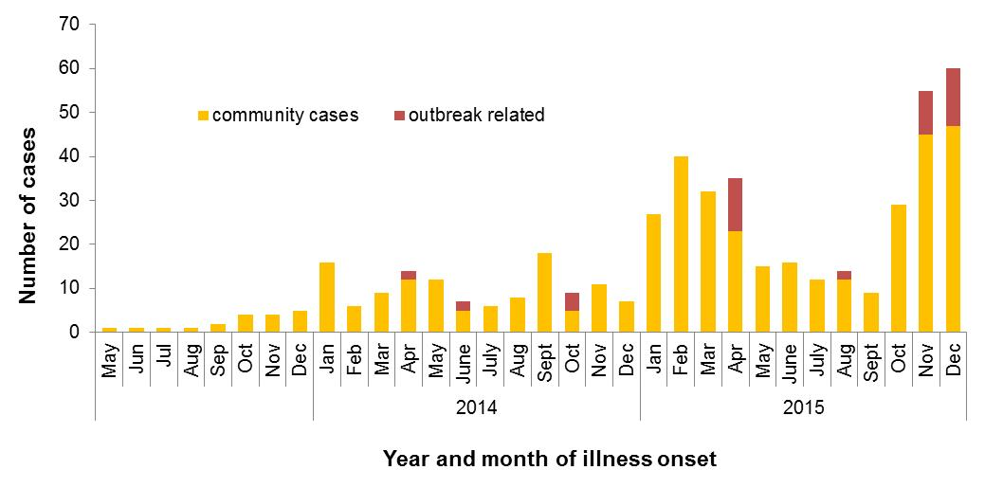

Figure 2 Notifications of *Salmonella* Typhimurium PFGE 0001 in WA, May 2013 to December 2015

# Non-foodborne disease outbreaks and outbreaks with an unknown mode of transmission

There were 48 outbreaks of enteric disease in this quarter that appeared to be non-foodborne (Table 6). Of these, 42 outbreaks were ascribed to person-to-person transmission and six outbreaks had an unknown mode of transmission.

Table 6 Outbreaks with non-foodborne transmission, 4th Quarter 2015, WA



1 Deaths temporally associated with gastroenteritis, but contribution to death not specified

## Person-to-person outbreaks

In the 42 non-foodborne outbreaks that were suspected to be due to person-to-person transmission, 28 outbreaks (54%) occurred in RCFs, 6 each were in child care centres (14%) and hospitals and one each on a cruise ship and at a restaurant. The causative agent for 22 (46%) outbreaks was confirmed as norovirus. The remaining 24 (54%) outbreaks were of unknown aetiology as specimens were either not collected (n=12), were negative for common viral and bacterial pathogens (n=9) or viral testing was not requested (n=3).

A total of 936 people were affected in these 42 outbreaks, with 9 reported hospitalisations and three associated deaths. The number of person-to-person outbreaks in the 4Q15 was similar to the fourth quarter 4QM (n=38).

**Person-to-person outbreaks of significance: Birthday party 13 year olds 10/15/PTY**

There were reports of people becoming ill after attending a 13 year old’s party at a Sports Centre/restaurant on 9th October. Attendees were sent a questionnaire on illness and food eaten at the party. Of the 17 people who completed the questionnaires, 12 reported diarrhoea and/or vomiting. Average duration of diarrhoea was 12 hrs and average duration of vomiting was 26 hours. The average incubation period was 34 hours. The symptoms, incubation period and duration of illness suggest the outbreak was due to norovirus. One of the parents who did not attend but was the father of a case also became ill and was diagnosed with norovirus. There was evidence of other person-to-person transmission. The analytical study did not identify any specific foods that were associated with illness. The evidence suggests person-to-person transmission at the party, although the ill person at the party was not identified.

## Outbreaks with unknown mode of transmission

There were six outbreaks in this quarter with an undetermined mode of transmission, with 65 people ill, one hospitalisation and no deaths. Five of these outbreaks were in RCFs, where the most common symptom reported was diarrhoea, and vomiting was reported infrequently, which is not typical of norovirus outbreaks in RCF settings. In four outbreaks stool specimens were collected and tested, but were negative for common bacterial and viral pathogens. No specimens were collected for one outbreak.

The sixth outbreak with an unknown mode of transmission involved 12 cases of gastroenteritis on a floating accommodation vessel attached to an oil platform. The reporting officer thought the outbreak was due to a temperature-abused food item served at a lunch but no specimens or samples were collected.

# Site activities

During the fourth quarter of 2015, the following activities were conducted at the WA OzFoodNet site:

* Ongoing surveillance of foodborne disease in WA.
* Monitoring culture-independent nucleic acid amplification diagnostic testing in private laboratories and impact on notification rates.
* Investigation of five foodborne outbreaks.
* Investigation and monitoring of 42 person-to-person gastroenteritis outbreaks and six outbreaks with unknown mode of transmission.
* Ongoing investigation of a community-wide increase in one *Salmonella* type.
* Responded to national OzFoodNet enteric disease surveillance requests.
* Attended six-monthly meeting of Department of Agriculture and Food, Western Australia (DAFWA) and WA Department of Health (DoHWA) to discuss zoonotic diseases.
* Attended the national OzFoodNet face-to-face meeting in Newcastle, NSW which included attending the Advance Outbreak Investigation Workshop.
* Attended *Salmonella* and Egg workshop in WA conducted by Dr Kapil Chousalkar from University of Adelaide.
* Interviewing *Salmonella* Enteritidis cases regarding travel status and attempting to identify risk factors in locally acquired cases.
* November update of Public Health Unit nurses on enteric disease investigations.
* Together with the Food Unit, conducted training in November of environmental health officers at a one day workshop titled “Foodborne outbreak investigation training”.
* Continuing to work with PathWest on implementation of MLVA typing of *S*. Typhimurium isolates and PCR testing of bloody stools for STEC.
* Chairing the Series of National Guidelines (SoNG) working group for *Listeria* infection.
* Membership of OzFoodNet working groups on:
  + Outbreak register
  + Foodborne disease tool kit
  + Egg-related outbreaks
  + Culture-independent testing
* Participation in monthly national OzFoodNet teleconferences.

# References

1. Hall G, Kirk MD, Becker N, Gregory JE, Unicomb L, Millard G, et al. Estimating foodborne gastroenteritis, Australia. Emerg Infect Dis 2005;11(8):1257-1264.
2. OzFoodNet Working Group. A health network to enhance the surveillance of foodborne diseases in Australia. Department of Health and Ageing 2013. www.ozfoodnet.gov.au/internet/ozfoodnet/publishing.nsf/Content/Home-1 [14/03/2012].

This document can be made available in alternative formats on request for a person with a disability.

© Department of Health 2016