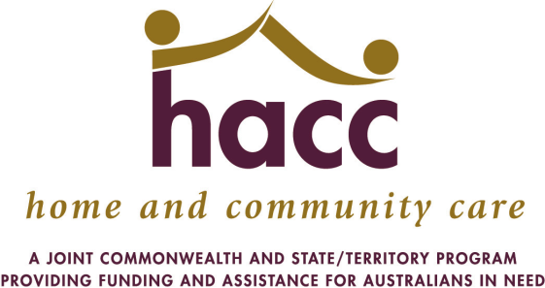
 | HOME and COMMUNITY CARE
 | 2016/17 GROWTH FUNDING APPROVALS
 | Organisation |  | Recurrent
 |  |  | $ (FYE)
 | Albany Community Care Centre (WA) Inc |  | 39,208
 | Albany Senior Citizens MoW |  | 36,398
 | Alzheimer's Australia WA Ltd |  | 488,914
 | Astley Care Inc |  | 66,770
 | Australian Asian Association of WA Inc |  | 130,083
 | Avivo: Live Life |  | 155,209
 | Bayswater Extended Community Help Organisation Inc |  | 36,750
 | Bess Home and Community Care Inc |  | 56,250
 | Bridgetown Meals On Wheels |  | 4,890
 | Brightwater Care Group (Inc) |  | 26,750
 | Capecare |  | 62,381
 | Care Options Inc |  | 157,452
 | Carnarvon Medical Services Aboriginal Corp |  | 1,296
 | City of Belmont |  | 62,553
 | City of Canning |  | 31,807
 | City of Cockburn |  | 100,028
 | City Of Gosnells |  | 29,939
 | City of Kalgoorlie/Boulder |  | 13,580
 | City of Stirling |  | 343,319
 | City of Subiaco |  | 17,184
 | City of Wanneroo |  | 13,906
 | Community First International Ltd |  | 148,850
 | Community Home Care Bunbury |  | 93,339
 | Derby Home And Community Care |  | 4,017
 | Goldfields Health Region |  | 12,515
 | Great Southern Health Region |  | 16,268
 | Halls Creek Community Care Inc |  | 6,255
 | Harold Hawthorne Senior Citizens Centre And Homes |  | 16,624
 | Harvey Health And Community Services Group |  | 102,003
 | Independent Living Centre of WA Inc |  | 367,072
 | Melville Cares |  | 348,901
 | Mercy Community Services Inc |  | 78,367
 | Organisation |  | Recurrent
 |  |  | $ (FYE)
 | Midwest Health Region |  | 161,476
 | Ngaanyatjarra Health Service |  | 20,395
 | Ngangganawili Health Service |  | 20,064
 | Nindilingarri Cultural Health Services |  | 7,990
 | Paupiyala Tjarutja Aboriginal Corporation |  | 4,627
 | Peel Community Care Inc |  | 11,161
 | People Who Care Inc. |  | 292,071
 | Rise - Network Inc |  | 677,835
 | Share And Care Community Services Group Inc. |  | 147,084
 | Shine Community Services |  | 43,353
 | Shire of Dowerin |  | 998
 | Shire of Esperance |  | 26,114
 | Shire of Kalamunda |  | 6,000
 | Shire of Manjimup |  | 22,607
 | Shire of Narrogin |  | 4,000
 | Shire of Wagin |  | 4,000
 | Silver Chain Group Limited |  | 1,536,255
 | South West Health Region |  | 16,546
 | Southern Cross Care WA Inc |  | 6,843
 | St Ives Care Pty Ltd |  | 262,225
 | Technology Assisting Disability WA Inc |  | 300,368
 | Town of Bassendean |  | 26,465
 | Town of Cambridge |  | 10,317
 | Umbrella Multicultural Comm. Care Svcs Inc. |  | 193,587
 | Uniting Church Homes |  | 7,966
 | Volunteer Task Force Inc |  | 652,937
 | WA Country Health Services Kimberley |  | 24,462
 | Wheatbelt Health Region |  | 52,411
 | Yaandina Family Centre |  | 9,265
 | * Note Current as at 30 June 2017 |  | 7,618,300

