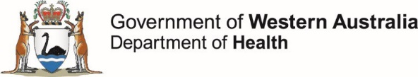
Healthy Options WA Food and Nutrition Policy
Request for Exemption for Select Business Catering or Fundraising Event
Purpose

To ensure that a wide range of healthy choices are available to staff members and visitors at all times, all fundraising activities that occur on WA health system entity premises and all business catering paid for using WA health system entity funds, are subject to the Mandatory Policy MP 0142/20 Healthy Options WA Food and Nutrition Policy.

Upon written request and at the discretion of the Chief Executive of a Health Service Provider or the Director General of the Department of Health, select business catering or fundraising events may be granted exemption from section 3.2 (iii) or section 3.3 (iii) of MP 0142/20, respectively.

What is a select event?

A select event is a major event which does not occur regularly or frequently. A select event may include, but is not limited to:
- a major fundraising breakfast, morning tea, lunch, or dinner (including a ball or gala)
- awards nights
- official announcements or ceremonies
- major end of year celebrations
The event type is at the discretion of the Chief Executive of a Health Service Provider or the Director General of the Department of Health.

Where an exemption is approved for a select business catering or fundraising event:

All food and drink provided must meet the following:
- a minimum of 50% of items offered are Green food and drinks
- the remainder may be Amber food and drinks, with no more than 25% of all drinks offered being intensely sweetened drinks
- no more than 20% of food and drink offered may be Red

Authorisation process

A written request for exemption must be submitted to the relevant authority for approval. An example exemption request form is provided on the next page. WA health system entities are responsible for recording the purpose of the select event and reason for the exemption.

WA health system entities must ensure they have local procedures which facilitate adherence to the minimum Policy requirements.

Further information:
- MP 0142/20 Healthy Options WA Food and Nutrition Policy
- Related Document: Healthy Options WA Making Health Choices Easier: How to Classify Food and Drink Guide
- Supporting Information: Healthy Options WA Food and Nutrition Policy website

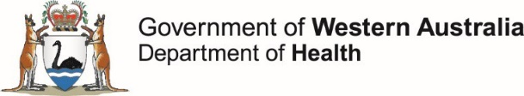
This template may be adapted for local use.
Healthy Options WA Food and Nutrition Policy
Request for Exemption for a Select Business Catering or Fundraising Event
WA health system entity: | Choose an item.
Type of event: | Choose an item.
Location of event: | Choose an item. | Click here to enter offsite location.
Date of event: | Click or tap to enter a date.
Name and purpose of event: | Click or tap here to enter text.
Reason for exemption request: | Click or tap here to enter text.
I confirm that the following Policy requirements will be met (use tick boxes):
- a minimum of 50% of items offered will be Green food and drinks |  |  | ☐
- the remainder will be Amber food and drinks, with no more than 25% of all drinks offered being intensely sweetened drinks |  |  | ☐
- no more than 20% of food and drink offered will be Red |  |  | ☐
Select event catering sample menu attached: |  |  | Choose an item.

REQUESTED BY:
Name:
Position:
HE number:
Department/Division:
Signature:
Date: | Click or tap to enter a date. | Telephone/Ext:
CHIEF EXECUTIVE OR DIRECTOR GENERAL AUTHORISATION
Approved: | ☐ Yes ☐ No
Name:
Position:
Signature:
Date: | Click or tap to enter a date. | Telephone/Ext:
All request for exemption forms must be recorded by the WA health system entity in accordance with the State Records Act 2000 and be made available for future audit purposes.

