International Day of People with Disability 2023 post event evaluation report

Monday 20 November, Perth Children’s Hospital Auditorium

The Disability Health Network and the Child and Adolescent Health Service (CAHS) held an event on 20 November 2023 for International Day of People with Disability. The event was attended by over 100 people joining online and in-person. Participants included clinical and non-clinical staff, representatives from disability service providers, and community members.
The event theme was ‘Supporting the journey: Empowering young people with disability in healthcare from childhood to adulthood’. The day started with a wonderful array of art and craft activities aligning with our theme of a journey for children and families in the Perth Children’s Hospital (PCH) atrium. This included a collaborative art piece coordinated by Sally-Anne Gamble, Aboriginal artist and mental health worker in Child and Adolescent Mental Health Service. During the morning, children, parents and carers, visitors and staff added drawings, dots and patterns which represented something meaningful to them. The morning event was hosted in collaboration with Kiind, an organisation which supports families raising children living with disability, developmental delay, autism, genetic, rare, undiagnosed and/or chronic conditions. Kiind staff were available to provide information and support to parents, carers, and families.
The afternoon event included a welcome to country by Sandra Harben, with master of ceremonies shared by Tayla Taseff the consumer co-chair of CAHS Disability Access and Inclusion Committee member and Jocelyn Franciscus, Co-Lead of the Disability Health Network. The Executive Director of CAHS and the Director of Health Networks officially launched the event which was attended by the Minister of Health and Mental Health, Director General of WA Health, Chief Psychiatrist and CAHS Board members.
The event featured a thought-provoking panel discussion which included people with lived experience of disability, service providers, and health staff sharing their insights and perspectives on transition. Dr Bethany Kloeden followed the panel discussion and presented on the Neurodiversity Care Plan and supports being trailed in the PCH emergency department. The keynote speaker, Georgia Inglis, was unavailable on the day due to illness, but recorded her presentation at a later stage that is available online.
A recording of the event is also available online.
The Hospital Stay Guideline Easy Read booklets for consumers, Disability Health Profile form (DHP), and the PCH child friendly version of the DHP, the What Matters to Me poster were also showcased.

Unfortunately, there were significant, unforeseeable technical issues experienced on the day including:
- Loss of auditorium audio resulting in handheld microphones being used connected to a standalone speaker for participants in the auditorium, and a separate microphone on the lectern to capture audio for online participants. This resulted in a loss of audio quality for people in the room, which limited their ability to hear and engage with the speakers.
- Online participants joining from outside WA Health could not connect to the live event.
- The Keynote Speaker, Georgia Inglis, becoming unwell on the day of the event and unable to participate.
These challenges impacted the feedback received on the day as well as via the online evaluation, however, the team garnered many lessons as a result to improve future events (see more information in the lessons learnt section).

Quantitative evaluation results
Event attendees were asked to complete a survey online to evaluate the event (see Appendix 1). Paper copies were offered to in-person attendees, but none were requested.
There were 33 responses to the post-event evaluation survey. Most respondents attended in person (76%). Most respondents identified as a health staff member (61%) or a family member, friend, carer or informal support person for a person with disability (27%).
Option | Total | Percent
Person with disability | 4 | 12%
Family member, friend, carer or informal support person for a person with disability | 9 | 27%
Health staff member | 20 | 61%
Disability service provider (e.g. support worker, support coordinator or management) | 5 | 15%
Primary health practitioner | 1 | 3%
Community practitioner | 2 | 6%
Other (please specify below) | 5 | 15%
Not answered | 0 | 0%
*Note: respondents could choose more than one option to describe themselves and responses are over 100%.

When asked how they heard about the event, most respondents indicated via direct email (79%), followed by word of mouth (24%), Health Happenings (12%), and Newsletter (12%).
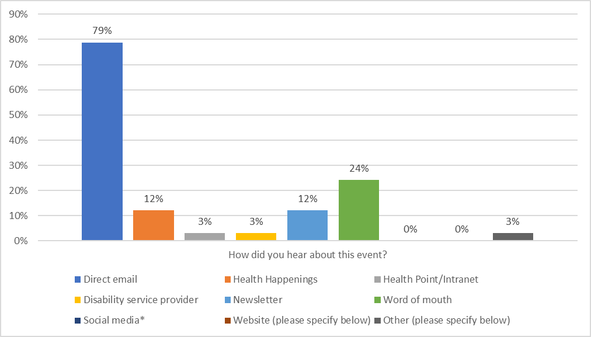
*Note: Respondents could choose more than one option to indicate how they heard about the event. Social media options included LinkedIn, Facebook, Instagram, and X (Twitter).

When asked how satisfied they were with the event overall, most respondents (84%) were very satisfied or satisfied.
Most respondents agreed or strongly agreed that the event helped increase their understanding of supporting the journey of young people with disability from paediatric to youth and adult services (88%).
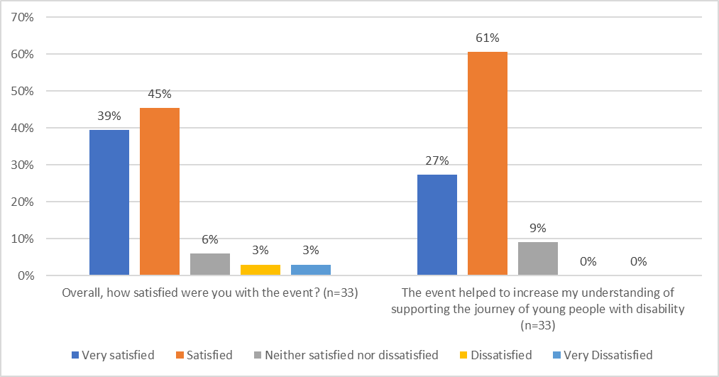

Of those who responded, most were very satisfied or satisfied with the event registration process (93%). Of the in-person attendees who responded to the survey, most were very satisfied or satisfied (92%) with the venue and most of the online attendees who responded to the survey were very satisfied or satisfied (76%) with the online access.
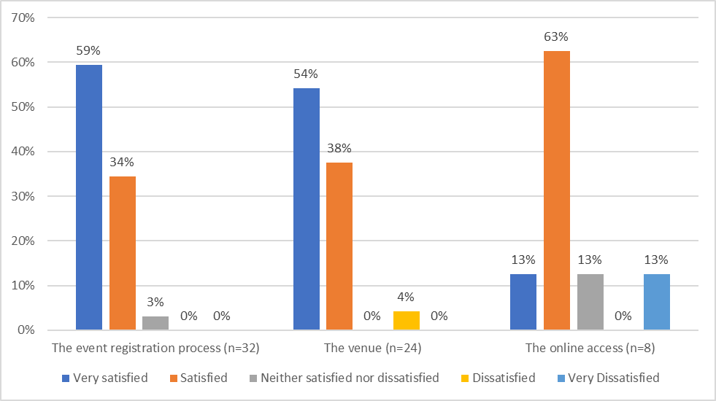
Of those who responded, most were very satisfied or satisfied with the panel discussion (87%) and the presentation by Dr Bethany Kloeden (85%).
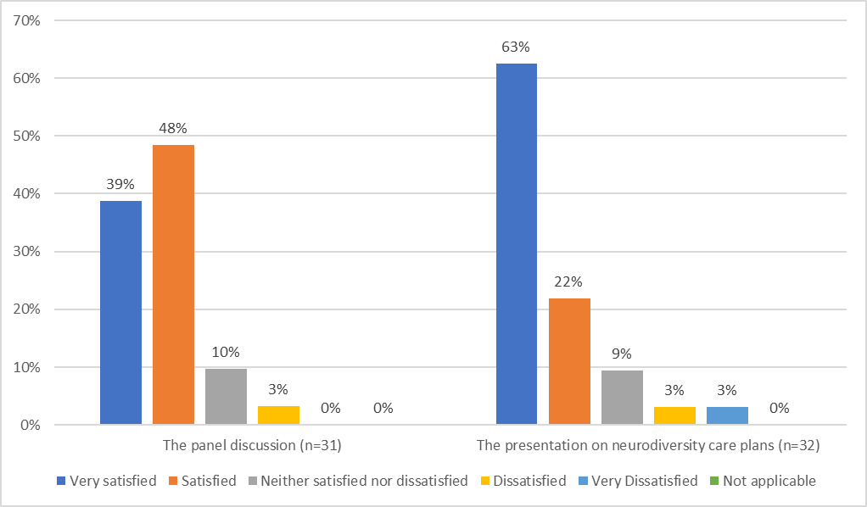

Qualitative evaluation results and lessons learnt
When asked what they enjoyed most about the event, responses (n=20) included the following.
Theme | Evidence | Lessons learnt
Several positive comments about the presentations and panel discussion, particularly the work being undertaken by the team implementing the neurodiversity care plans at PCH. | - “Hearing about what PCH is doing to make a more accessible services and how they and Dept of Health are working with lived experience”  - “The varied perspectives on this topic including from young people themselves”  - “I very much enjoyed hearing from the panel as their experiences helped paint a clearer picture of the current state of the transition from child to adult care”  - “Learning about the practical solutions to support children with disability and their carers”  - “Loved hearing a [sic] the neurodiversity care plan journey”  - “Opportunity for open discussion around disability and access to services and the barriers that exist” | - Presentations on practical applications of inclusive systems are well received  - Diverse topics are beneficial  - Discussing the topic of disability and health in an open forum is beneficial  - Promoting the practical ways that the Department of Health and our partners are working to promote inclusion is beneficial
Several respondents also enjoyed the emphasis on people with disability and lived experience. | - “Fabulous integration of loved [sic] experience sets the bar high for health”  - “Inclusive and informative”  - “The input from people with lived experience in the panel discussion”  - “Seeing people with lived experience taking an active part in the event” | - It is essential to have people with lived experience involved in all aspects of the event from planning, MC, and presenters. It is important that this involvement is clear to all attendees.

When asked for any suggestions to improve future events, responses (n=9) included:
Theme | Evidence | Lessons learnt
Some comments identified the difficulties with the audio. | - “The sound was inadequate and it was extremely difficult to hear most presenters”  - “I came in to work especially for the event and was pretty disappointed to not have the key note speaker available and to be virtually unable to hear the other presenters as the sound was so poor”  - “The venue was very dark and speakers too far away. Sound was very echoey” | - In case of future audio failures, we will ensure all participants move to the front of the auditorium.  - Testing of the alternative option for in-room audio should have occurred more extensively to ensure it was adequate.  - What worked well on the day: It was beneficial that the organising team were on site 3 hours prior to the event to manage the sound issue, and one person was the point of contact for the technicians.  - Provide anyone using a handheld microphone with a quick introduction on how to hold a microphone so that it picks up their voice (handheld microphones are directional, the top must point to the person’s mouth, and it must be within 15cm to pick up their voice).
Some people identified alternative information to be included in the event | - “More panel members, more representation of mental health and hidden disabilities”  - “I would very much like time dedicated towards audience questions and discussion with the panel”  - “There wasn't enough information presented about how the service currently runs to transition youth to the adult system. There could have been more information provided about this and how support services could assist with the transition and help set expectations on what this might be like for them.” | - Consideration could be given to include a Q&A option in future events.  - Future partnership with the Mental Health Commission and Office of the Chief Psychiatrist to run an IDPWD event will be considered.  - Inclusion of hidden disability can be considered at future events via the types of presentations and/or people with disability who are included in the event.
Online access was an issue for many people who were not WA Health employees | - “1) Allow the online access to be accessed by people who do not work for WA Health, this is the second time in three years where I have had to log in alternatively to watch the event.” | - Confirm with all audio visual and IT support staff involved that the link meets requirements and if possible, test link alongside the AV supports prior to event.  - Consideration should be given to the accessibility of alternative online platforms.  - Ensure any people who are managing the MS Teams (i.e. sharing the presentation etc.) are listed as “presenters” on the MS Teams link
Concerns were raised by one attendee regarding the authenticity of the inclusion of people with disability | - “2) People with lived experience should be front and centre of the event, some of the panel questions were insensitive and came across as "health knows best and you just do as we say". 3) The overall attitude from some of the CAHS presentations was patronising, not impressed with their rhetoric or accessibility standards. 4) One panel member with disability was ignored and their parent was asked about their care with no participation from the person with lived experience- this is completely unacceptable, rude and discriminatory behaviour. Very poor panel adjudication this year.” | - The IDPWD event has people with disability represented throughout the planning and design. However, the 2023 organising committee should reflect on this feedback and identify if there were unintended issues with the presentations and/or messaging.  - One panel member was joined onstage by their son who has a disability and is non-verbal. This was not made clear to the attendees. Consideration should be given to the most appropriate way of introducing people with a disability that impacts communication.
Concern was raised by one respondent over the accessibility of the presentations | - “5) No presentations were made in accessible formats ahead of the event, meaning I could not follow the flow and information being discussed” | - Where possible, an accessible format of the event presentation should be provided to attendees prior to the event.
Concerns were raised by one respondent over the health and safety of in-person events given the current spike in COVID presentations and the risk to people with disability or chronic health conditions | - “6) Given the current COVID19 situation, holding a face to face event should have been the last option and greater access for people to attend remotely. The potential for spreading a potentially deadly virus was dismissed, considered not as important as "let's get together and have a coffee".” | - In- person events offer a rare and valuable opportunity for networking and connecting with people from across the disability sector. The event was run in accordance with current COVID protocols.  - Consideration could be given to clearer signage about optional face masks and hand sanitiser.  - Consideration will be given to the modality of future events based on the most up-to-date health recommendations regarding COVID and to optimise inclusion of regional and remote attendees and presenters.

Conclusion
Attendees enjoyed the variety of perspectives from the guest speakers and panel members, including people with disability and clinicians. A future recommendation is to continue incorporating a variety of speakers for future events to allow for a range of perspectives, specifically branching out into the space of mental health and disability.
Despite using a range of channels to promote the event, only a few were successful. It is recommended that direct email is used for promotion of future events and that stakeholders are encouraged to share the event with their networks.
Where possible, an improvement for future events is to share links to document and presentations prior to the event and to share the links in the messenger function for online attendees.
Despite unforeseen technical difficulties and changes to the program due to the illness of the keynote speaker, the event was successful in its aim of informing attendees of supporting young people with disability through transition.

Appendix 1: Example survey
- Did you attend online or in person?
- Online
- In person
- How would you describe yourself? I am a...
Please select all that apply
- Person with disability
- Family member, friend, carer, or informal support person for a person with disability
- Health staff member
- Disability service provider (e.g. support worker, support coordinator or management)
- Primary health practitioner
- Community practitioner
- Other (please specify below)
Please specify here:
- How did you hear about this event?
Please select all that apply
- Direct email
- Health Happenings
- Health Point/Intranet
- Disability service provider
- Newsletter
- Word of mouth
- Social media - LinkedIn
- Social media - Facebook
- Social media - Instagram
- Social media - X (formerly Twitter)
- Website (please specify below)
- Other (please specify below)
Please specify here:
- Overall, how satisfied were you with the event?
Please select only one item
- Very Dissatisfied
- Dissatisfied
- Neither satisfied nor dissatisfied
- Satisfied
- Very Satisfied
- To what extent do you agree that this event helped to increase your understanding of supporting the journey of young people with disability from paediatric to youth and adult services?
Please select only one item
- Strongly Disagree
- Disagree
- Neither agree nor disagree
- Agree
- Strongly Agree

- Please indicate your satisfaction with following aspects of the event, where 1=very dissatisfied and 5=very satisfied.
 | 1 | 2 | 3 | 4 | 5 | NA
Event registration process
Venue
Online access
Keynote speaker
Panel discussion
Presentation on neurodiversity care plans

- What did you enjoy most about the event?

- What, if any, suggestions do you have to improve future events?

